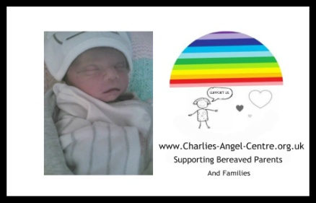
Office use only

Charlies-Angel-Centre.org.uk

Gift Aid Declaration Form
Title Initial Surname
1

House Name

Address Line 1

Town

County Postcode

Telephone Number
Email

If you are a UK taxpayer, the value of your donations can increase by 25% under the Gift Aid scheme
2
– At no additional cost to you! Please tick the box below to join the Gift Aid scheme.

I am a UK taxpayer*. Please treat all donations I make or have made to
Charlies-Angel-Centre for the past 4 years as Gift Aid donations until further notice.
* Please be aware that you must have paid an amount of income and/or capital gains tax at least equal to the amount of tax reclaimed by all charities and Community Amateur Sports Clubs on all your donations in the tax year (6th April one year to 5th April the next). We can currently receive an extra 25p for every £1 you donate. Other taxes such as Council Tax and VAT do not qualify.
Please let us know if your tax circumstances or name/address
Change so that we can update our records. Date.

It may be that having read the information on this form you feel that your donation does not qualify. If this is the case please tick the relevant box below and return this form to us. This will ensure you are not asked to complete a Gift Aid form in the future, should you choose to support us again.
3

I cannot complete the Gift Aid form because: I am not a UK taxpayer
I do not pay enough tax each year to cover the tax on the gift

Other (please state)

Please return your Gift Aid form together with your donation. If you are only returning the Gift Aid form, please send it to: Charlies-Angel-Centre, 92 Sissons Road, Middleton, LS10 4JY or Email Charliesangelcentre@hotmail.com
4
Thank you for your support

Gift Aid Key Facts
When Charlies-Angel-Centre Receives a donation from a UK taxpayer, we are entitled to claim an amount of tax (calculated at the basic rate of income tax in that year) paid on that donation. Once you have given your permission for us to do this on your behalf (by filling in this Gift Aid form), there is no need for you to do anything else.
All that is required is that the amount of income and/or capital gains tax
you pay in a given tax year (6th April one year to 5th April next year) is at least equal to the amount of tax claimed by all charities and Community Amateur Sports Clubs on all your donations. As this amount is calculated over the whole tax year, there is no requirement that tax is paid regularly – it is purely
A question of how much has been paid in the tax year as a whole. Other taxes such as Council Tax or VAT do not qualify for Gift Aid.
The amount of tax we claim will be 25% of the total value of
Your donations in that tax year. Furthermore, if you are a higher tax payer, you are also entitled to claim the difference between the basic rate which we will claim and the amount of tax you have actually paid. For further details on how you can do this, please contact your tax office. If your tax situation changes and your gifts will no longer be eligible for the Gift Aid scheme please contact us and we will amend your record accordingly.

